1. **BIT SUBTRACTION**

**EXP NO: 6**

**AIM:** To write an assembly language program to implement 16-bit subtraction using 8085 processor.

**ALGORITHM:**

1) Start the program by loading a register pair with address of 1st number.

2) Copy the data to another register pair.

3) Load the second number to first register pair.

4) Subtract the two register pair contents.

5) Check for borrow.

6) Store the value of difference and borrow in memory locations.

7) End.

**PROGRAM:**

MVI B, 00

LHLD 4200

XCHG

LHLD 4202

MOV A, L

SUB E

MOV L, A

MOV A, H

SBB D

MOV H, A

JNC SKIP

INR B

SKIP: SHLD 4204

MOV A, B

STA 4206

HLT

**INPUT:**

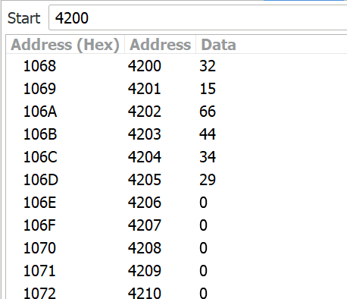

**OUTPUT:**

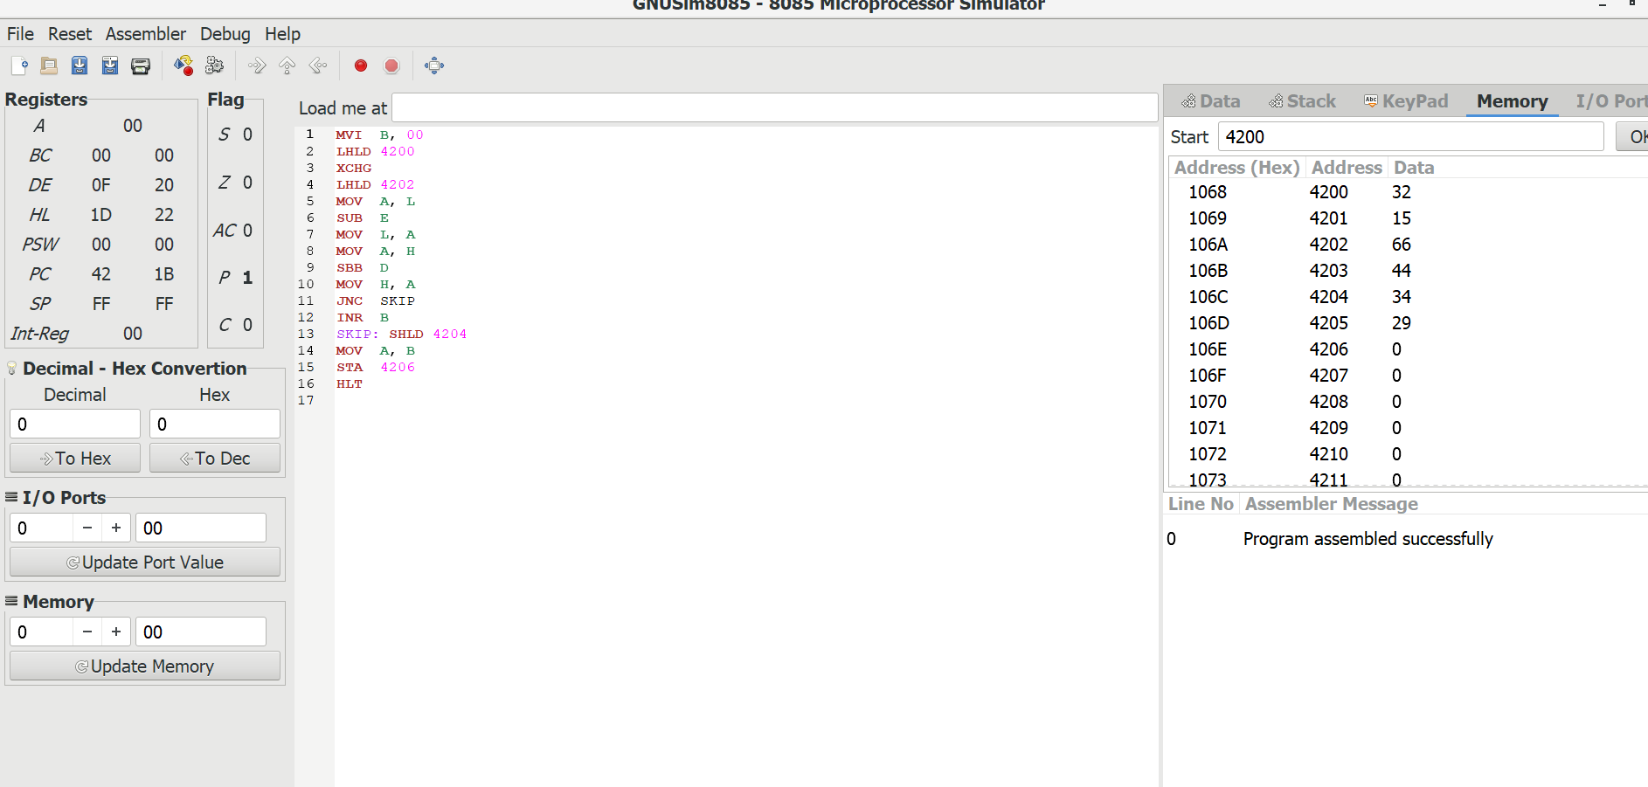

**RESULT:** Thus the program was executed successfully using 8085 processor simulator